DOCUMENTATION

ASSIGNMENT 1

STUDENT NAME: Veres Noémi
GROUP: 30423

CONTENTS

1. Objective 3
2. Problem analysis, modeling, scenarios, use cases 3
3. Design 5
4. Implementation 6
5. Results 7
6. Conclusion 7
7. Bibliography 7

Objective
The main objective of Assignment 1 is to design and implement a polynomial calculator with a dedicated graphical interface through which the user can insert polynomials, select the mathematical operation to be performed and view the result.
The sub-objectives are the following:
- Analyze the problem and identify requirements
- Design the polynomial calculator
- Implement the polynomial calculator
- Test the polynomial calculator

For this assignment, we had several methods to implement. The operations are addition, subtraction, multiplication, division, derivative and integral. The problem analysis will be detailed in the next chapter: 2. Problem analysis, modeling, scenarios, use cases. The design of the polynomial calculator had to be made in accordance with a specific architectural pattern. I used the Model View Controller pattern, which is explained in the 3. chapter. The implementation is detailed in the 4. chapter, where all the classes are presented and their main methods. Whenever writing a program, testing is an essential part of it, however, we have to remember that “The absence of evidence is not necessarily evidence of absence”. Even though all the test cases are running correctly, this does not mean that our program is free of errors as we cannot cover all the special cases. We can only minimize the chance of running into problems. Further information about testing the polynomial calculator can be found in the 5. chapter.

Problem analysis, modeling, scenarios, use cases
The functional requirements of this problem are:
- The polynomial calculator should allow users to insert polynomials
- The polynomial calculator should allow users to select the mathematical operation
- The polynomial calculator should add two polynomials
- The polynomial calculator should subtract two polynomials
- The polynomial calculator should multiply two polynomials
- The polynomial calculator should divide two polynomials
- The polynomial calculator should derivate a polynomial
- The polynomial calculator should integrate a polynomial

Non-Functional requirements might include:
- The polynomial calculator should be intuitive and easy to use by the user
- The polynomial calculator should be reliable, for the user to trust in our application
- The polynomial calculator should be performant in time because the user does not want to wait a lot for obtaining the result

Now the use cases will be presented.

Use Case: add polynomials
Primary Actor: user
Main Success Scenario:
1. The user inserts the 2 polynomials in the graphical user interface.
2. The user selects the “add” operation
3. The user clicks on the “compute” button
4. The polynomial calculator performs the addition of the two polynomials and displays the result
Alternative Sequence: Incorrect polynomials
The user inserts incorrect polynomials (e.g. with 2 or more variables)
The scenario returns to step 1

Use Case: subtract polynomials
Primary Actor: user
Main Success Scenario:
1. The user inserts the 2 polynomials in the graphical user interface.
2. The user selects the “subtract” operation
3. The user clicks on the “compute” button
4. The polynomial calculator performs the subtraction of the two polynomials and displays the result
Alternative Sequence: Incorrect polynomials
The user inserts incorrect polynomials (e.g. with 2 or more variables)
The scenario returns to step 1

Use Case: multiply polynomials
Primary Actor: user
Main Success Scenario:
1. The user inserts the 2 polynomials in the graphical user interface.
2. The user selects the “multiply” operation
3. The user clicks on the “compute” button
4. The polynomial calculator performs the multiplication of the two polynomials and displays the result
Alternative Sequence: Incorrect polynomials
The user inserts incorrect polynomials (e.g. with 2 or more variables)
The scenario returns to step 1

Use Case: divide polynomials
Primary Actor: user
Main Success Scenario:
1. The user inserts the 2 polynomials in the graphical user interface.
2. The user selects the “divide” operation
3. The user clicks on the “compute” button
4. The polynomial calculator performs the division of the two polynomials and displays the result
Alternative Sequence: Incorrect polynomials
The user inserts incorrect polynomials (e.g. with 2 or more variables)
The scenario returns to step 1

Use Case: derivate a polynomial
Primary Actor: user
Main Success Scenario:
1. The user inserts the polynomial in the graphical user interface.
2. The user selects the “derivative” operation
3. The user clicks on the “compute” button
4. The derivative of the inserted polynomial is calculated and the result is displayed.
Alternative Sequence: Incorrect polynomial
The user inserts an incorrect polynomial (e.g. with 2 or more variables)
The scenario returns to step 1

Use Case: integrate a polynomial
Primary Actor: user
Main Success Scenario:
1. The user inserts the polynomial in the graphical user interface.
2. The user selects the “integral” operation
3. The user clicks on the “compute” button
4. The integral of the inserted polynomial is calculated and the result is displayed.
Alternative Sequence: Incorrect polynomial
The user inserts an incorrect polynomial (e.g. with 2 or more variables)
The scenario returns to step 1

Design
For this assignment, I have 4 packages inside ro.tuc.pt: GUI, logic, model, and utils, as I have used a specific architectural pattern, a so-called Model View Controller pattern. In the sub-packages, I grouped the classes which are correlated.
In the Model View Controller pattern, we have 3 main parts, it divides the application into 3 areas: processing, output and input. The Model contains data-related classes: Monomial and Polynomial, as one polynomial is built up of one or several monomials. By splitting the polynomial into monomials, we can perform operations easier on these smaller parts, and then by combining these results we obtain the final result. In the GUI package, we have 2 classes: View and Controller. In the View class, we implement the graphical user interface of the application, while the Controller class deals with the connection between the Model and the View, by implementing the ActionListener interface. The logic package contains the Business Logic, which are the operations like addition, subtraction, or multiplication. Finally, the utils package contains the Converter class, which converts a string to a polynomial, using regular expressions.
The following UML diagram shows us the dependencies between classes and the main methods of each class.
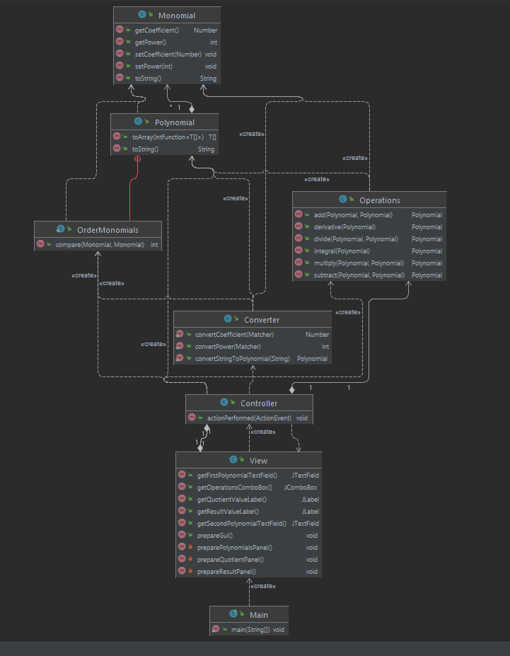

Implementation
Let us take each class separately and describe their main fields and methods.
The Polynomial class has one private field, a list of monomials. As for the methods, we have a constructor Polynomial(), which allocates a new ArrayList for our monomials. Apart from that, we have a toString() method, which converts a polynomial to a String, to display our result after the operations are made. Inside the Polynomial class, we have an inner class, the OrderMonomials class, in which we override the compare method of the Comparator interface. This will help us to sort our monomial by their power, the higher ones coming first.
In the Monomial class, we have 2 private fields, the coefficient, of type Number (as we might obtain not only integers, but also floating-point numbers at the division or by integrating), and the power, for which type integer is enough. We have a toString() method, similar to the Polynomial class, apart from the constructor, getters, and setters. This one is going into detail, as it converts each monomial to a String.
The View class is using Java Swing, to create a user-friendly graphical interface. We have man private fields here, of type JPanel, JLabel, JTextField, JCombobox – for selecting the operation and JButton – for computing. The constructor receives a String, which will be the name of our application as all frames must have a name. Other methods are prepareGui(), prepareResultPanel(), prepareQuotientPanel(), preaparePolynomialsPanel() and some getter, for returning the polynomial text field, the operation or the result. I placed labels in the frame, in order to inform the user what they have to do.
The Controller class has 2 private fields: view and operations, which are enough for making the connections between the View and Model. Apart from the constructor, we have an actionPerformed(ActionEvent e) method, which gets “the compute” command as a String. This is the time when the two inserted polynomials are read and the operation is also indicated. Using a switch case, we perform the different operations on the polynomials and finally we display the results.
In the Operations class, the operations are implemented. The user will be able to perform 6 operations: add, subtract, multiply, divide, integral and derivative. The add and subtract methods are similarly implemented, the result is obtained in the first polynomial. Each time we find the same power in the second polynomial, the coefficients will be added or subtracted, according to the operation. It might happen that a power is present only in the second polynomial. In this case, we will append this monomial to the first polynomial. The multiply operation is a bit more complex, first I multiplied all the terms of the second polynomial with the first monomial from the second polynomial and the result is stored in res1. Then, we go through the other monomials from the first polynomial and multiply with it the second polynomial each time. Doing so, we obtain a second result, stored in res2, which will be added to res1. This res1 will be returned in the end, containing the final result. The divide method is the most complex one. The dividend will be the polynomial with the higher degree and the other one will be the divisor. We divide the dividend with the first monomial from the divisor and we obtain a monomial. We then multiply back the dividend with this monomial and change the sign of the multiplication, which means that we subtract the result of multiplication from the dividend. We repeat this procedure for the other monomials from the divisor as long as the result of the subtraction will have a lower degree than the order of the divisor. To be clear, we have to mention that the result of each subtraction will be the new dividend each time. The derivative and integral methods are again similar, each one is implemented using an enhanced for loop, the coefficient and power of the monomials are changed according to the formula.
The Converter class has 3 methods: convertCoefficient, convertPower and convertStringtoPolynomial. These methods are using regular expressions to validate the input polynomials. First, we check if the input string is a polynomial, and then we can convert the string into polynomials. For this, we will have to split the polynomial into monomials and get the corresponding coefficients and powers. We had to be attentive, as some special cases might occur, for example, x might not have a coefficient specified explicitly, so this can be either 1, -1 or 0. Similar cases might appear for the power, which can either be 0 or 1 implicitly.
Finally, the Main class contains the main method, which will run our application.

Results
For testing the results, I used JUnit. For this, I had to add some dependencies to the pom.xml file.
As we have 6 operations, I made 6 test classes: AddOperationTest, DerivativeOperationTest, DivideOperationTest, IntegralOperationTest, MultiplicationOperationTest and SubtractOperationTest, these classes being placed in the test folder. I had the use the annotation @Test to denote that the used methods are test methods. For each one, I considered the examples from the provided presentation. In the provided examples some special cases might occur, for instance, monomials of a certain power might disappear after subtraction. It must be noted that some results are given in floating-point number representation. This is important for obtaining a result as precise as possible for division and integral, where the coefficients might be not only integers but also real numbers.

Conclusion
There were many concepts and also practical things that I have learned from this assignment. I learned how to divide the whole system into smaller parts, using a specific architectural pattern, a Model View Controller in this case. The 3 main parts of this architecture are the graphical user interface (GUI), business logic and data models. Using regular expressions was a real challenge because of the specific sub-cases and it took a lot of time. However, I enjoyed it, it was great to discover all of these cases and find a solution for them.
Implementing the methods was another main part of the assignment, where the mathematical background was important to really understand. In almost all the methods some specific cases might occur, so I had to thoughtfully implement all of them. I realized that I just cannot dive into implementing without thinking first or making a sketch on paper. I took some notes and wrote down some ideas and then I could implement the methods.
All in all, this assignment helped me divide a complex program into small subproblems, to efficiently solve them and then recombine them to obtain back the final required result.
The application can be further developed, for example, we could calculate the value of the polynomial in a certain number. Another functionality that could be implemented is the limit, which can be calculated in different points or when x approaches + or – infinity. I also did not make it to work the polynomial calculator correctly when a wrong input is inserted. In this case, only a message will be shown in the terminal. I should have informed the user about the wrong input in the application, asked them to correct the polynomials, and then check again the input. Multiple test cases could be implemented, covering almost all of the specific cases.

Bibliography

For this assignment, I mainly used the mvc source code, a template provided on our Microsoft Teams class.
The presentation provided on the course website was also useful, containing some suggestions about the design and theoretical background about polynomials: FUNDAMENTAL PROGRAMMING TECHNIQUES (dsrl.eu)

